GUDDETI YUGESH

Gyugesh74@gmail.com

Subject: Assignment work of AWS Essentials Batch-1, Day-3

**Project :1**

Windows Machine Instance

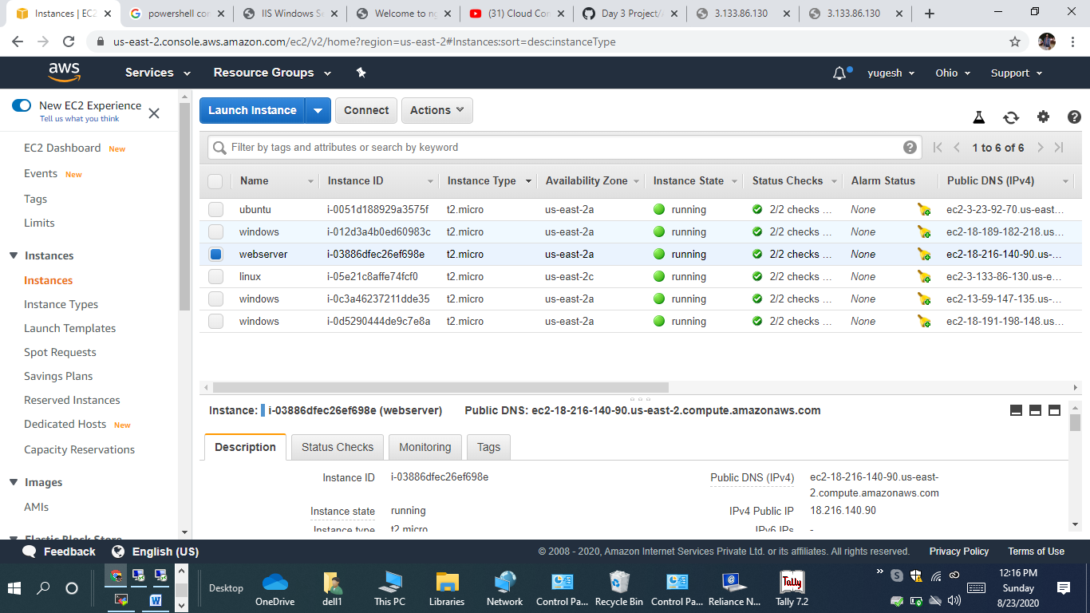

IIS: <http://18.191.198.148/>

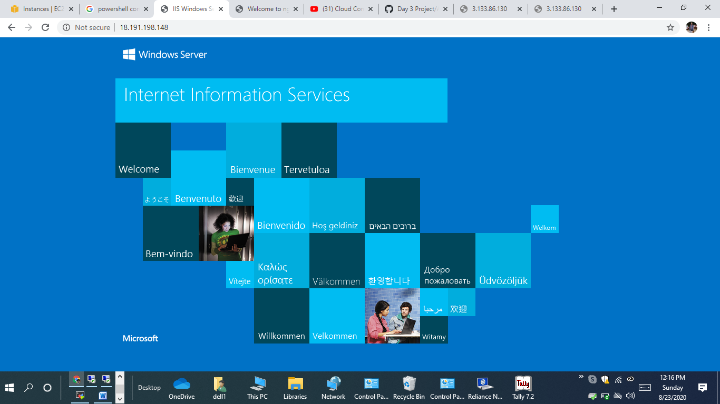

**Project:2**

Ubuntu Machine Instance

